**S.I.E.S College of Arts, Science and Commerce(Autonomous)**

**Sion(W), Mumbai –  400 022.**

**CERTIFICATE**

This is to certify that Miss.  **Kimaya Naik_**

Roll No. **TCS2324048** has successfully completed the necessary course of experiments in  the subject of  **Ethical Hacking** during the academic year   **2023 – 2024** complying with the requirements of **University of Mumbai**, for the course of  **T.Y.BSc Computer Science [Semester-VI].**

Prof. In-Charge

**Dr ABUZAR ANSARI**

Examination date:

Examiner’s Signature & Date:

Head of the Department College Seal

**Prof. Manoj Singh**

**Index Page**

|  |  |  |  |  |
| --- | --- | --- | --- | --- |
| **Sr. No** | **Description** | **Pg No** | **Date** | **Sign** |
| 1 | Use Google and Whois for Reconnaissance. | 3 |  |  |
| 2 | Use Crypt Tool to encrypt and decrypt passwords using RC4 algorithm.  Use Cain and Abel for cracking Windows account password using Dictionary attack and to decode wireless network passwords. | 4 |  |  |
| 3 | Using Traceroute, ping, ipconfig, netstat Command. Perform ARP Poisoning in Windows. | 6 |  |  |
| 4 | Using Nmap scanner to perform port scanning of various forms – ACK, SYN, FIN, NULL, XMAS. | 8 |  |  |
| 5 | Use Wireshark sniffer to capture network traffic and analyse. | 9 |  |  |
| 6 | Simulate persistent Cross Site Scripting attack. | 10 |  |  |
| 7 | Session impersonation using Firefox and Tamper Data add on. | 11 |  |  |
| 8 | Perform SQL injection attack. | 12 |  |  |
| 9 | Create a simple keylogger using Python. | 14 |  |  |
| 10 | Using Metasploit to exploit. | 15 |  |  |

**Practical No: 01**

Aim : Use Google and Whois for reconnaissance.

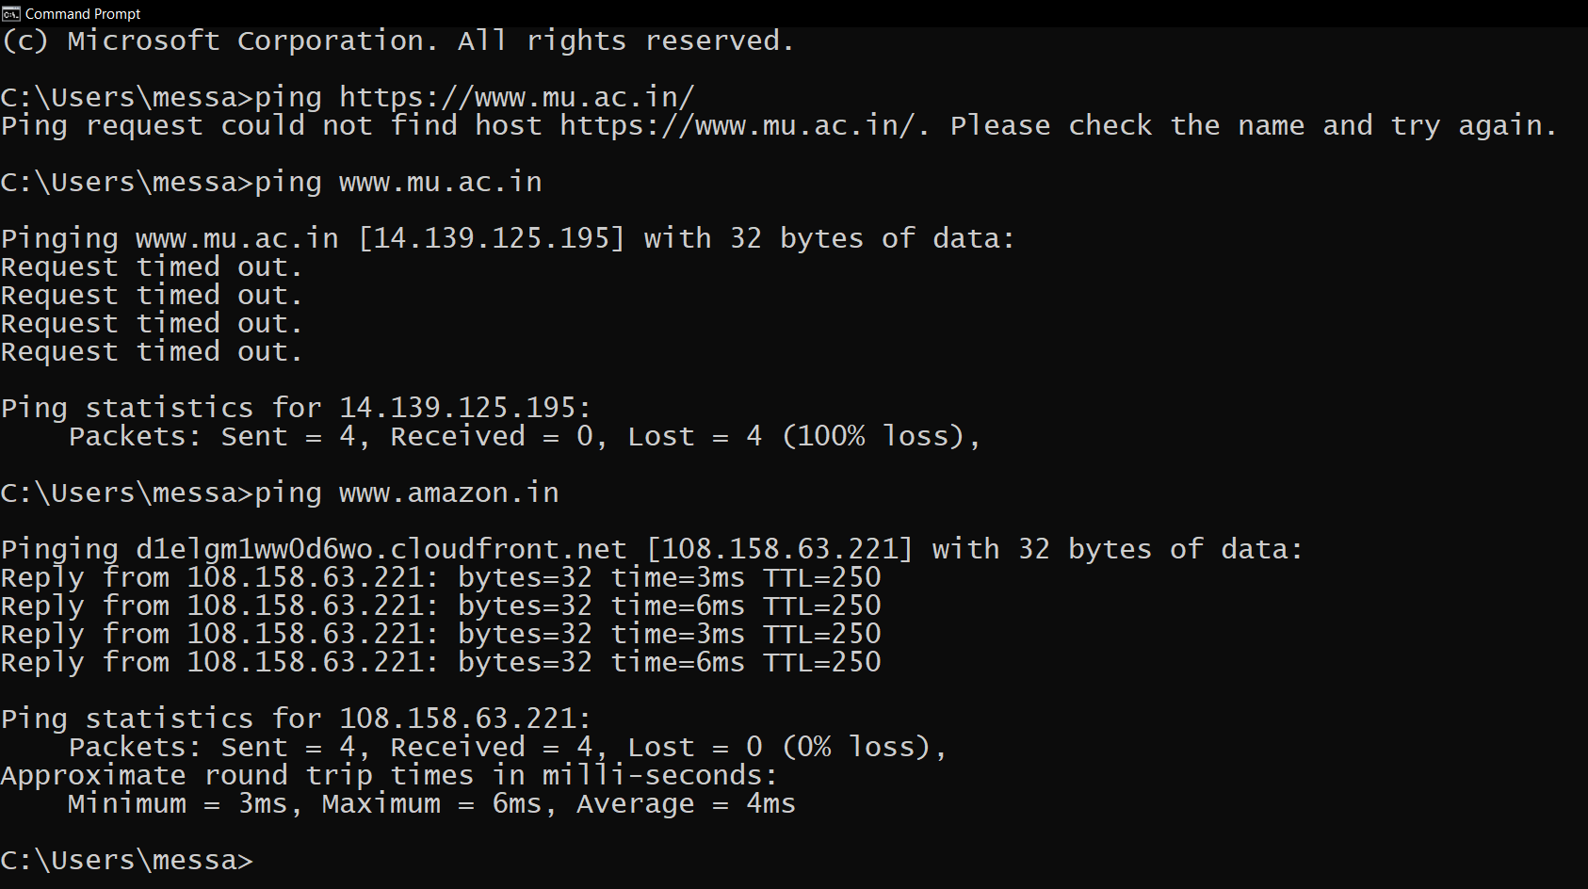

**Practical No: 02**

Aim : Use Crypt Tool to encrypt and decrypt passwords using RC4 algorithm.

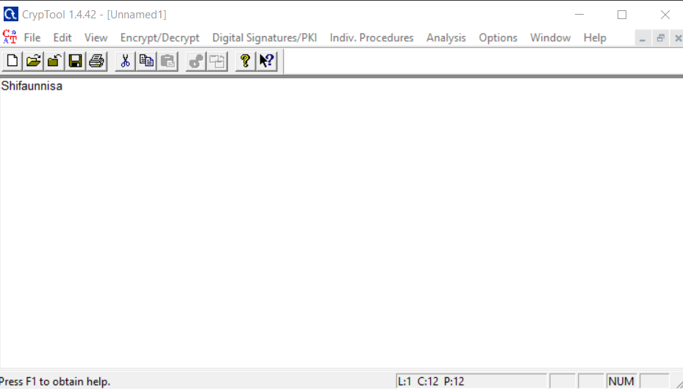

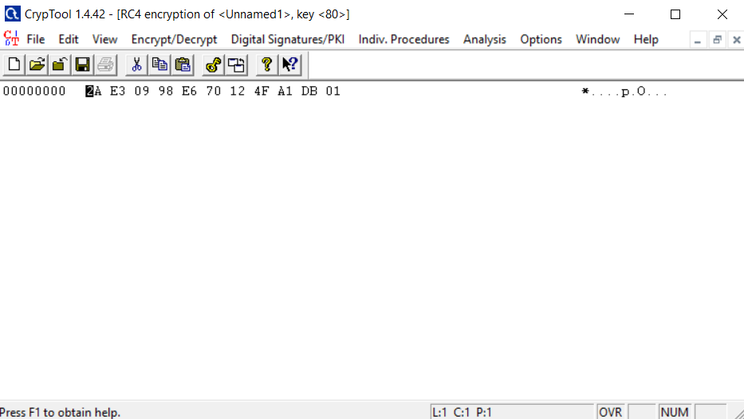

**Practical No: 03**

Aim : Using Traceroute, ping, ipconfig, netstat Command

Aim : Perform ARP Poisoning in Windows

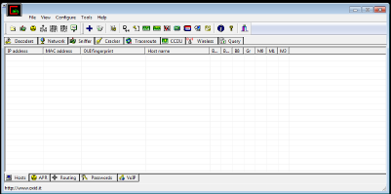

**Practical No: 04**

Aim : Using Nmap scanner to perform port scanning various forms – ACK, SYN, FIN, NULL, XMAS.

**Practical No: 05**

Aim: Use Wireshark sniffer to capture network traffic and analyse.

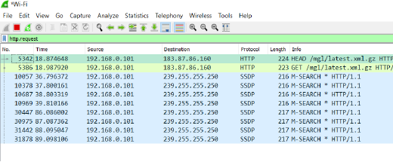

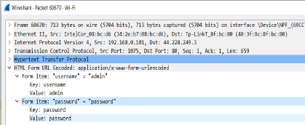

**Practical No: 06**

Aim: Simulate persistent Cross Site Scripting Attack.

**Practical No: 07**

Aim: Session impersonation using Firefox and Tamper Data add on.

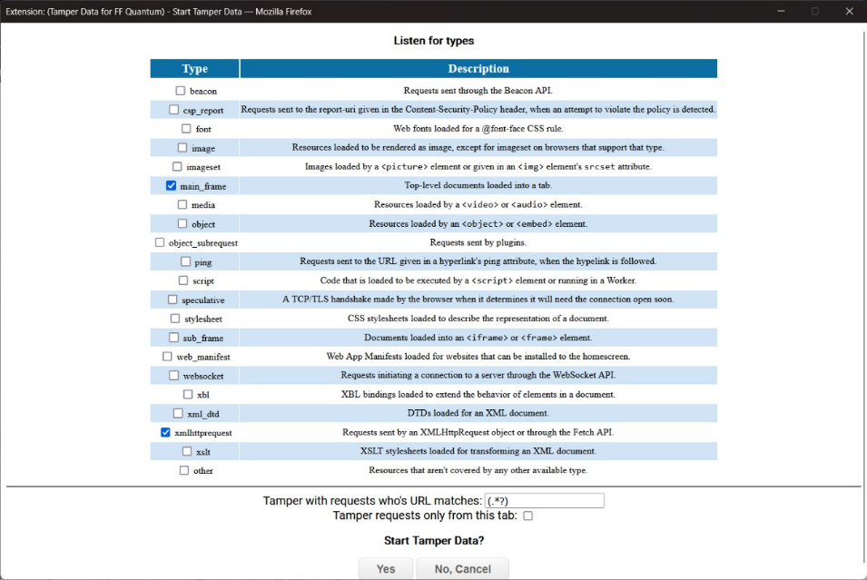

**Practical No: 08**

Aim : Perform SQL injection attack.

**Practical No: 09**

Aim : Create a simple keylogger using Python.

**Practical No: 10**

Aim: Using Metasploit to exploit (Kali Linux).

